**GET DATA FROM REST API USING**

**ALEXA SKILL**

**What is an Alexa Skill?**

The Amazon Echo is a hands-free speaker you control with your voice. Alexa is the voice service that powers Echo and allows customers to interact with the device. As third-party developers, we can create apps, or, in this case, "skills" that users can download and interact with. An Alexa skill might help you find a good book while another might give you information about your favourite TV Show. The possibilities are endless!

**Prerequisites**

* An Amazon developer account, created one [here](https://developer.amazon.com/login.html) if needed
  + This is required for building and managing skills
  + This is also required if you plan to use Login with Amazon (LWA) as your OAuth provider.
  + This is an Amazon account, so it can also be used as an Alexa user for testing
* An Alexa-enabled device associated with the above account
  + This can be an [Amazon device with Alexa](https://www.amazon.com/gp/browse.html?node=9818047011&ref_=fs_ods_fs_aucc_cp&pldnSite=1), or an [Alexa Voice Service (AVS) enabled device](https://www.amazon.com/b/ref=cp_aucc_ods?node=15443147011)
  + This can also be a virtual device like [echosim.io](https://echosim.io/) or [reverb.ai](https://reverb.ai/)
* An AWS account -- create one [here](https://console.aws.amazon.com/console/home) if needed
  + This is required for building and hosting [Lambda](https://aws.amazon.com/lambda/) functions, which are required for skills.

# **Five Steps to setup Alexa Skill**

Please refer to our [official documentation](https://developer.amazon.com/public/solutions/alexa/alexa-skills-kit/docs/steps-to-create-a-smart-home-skill) for detailed steps to creating a skill. However, it boils down to the following five easy steps:

1. Create the skill
2. Create the Lambda function
3. Configure the skill
4. Test
5. Publishing Alexa Skill to store
6. Issues & Solutions

# **Create the skill**

1. Go to <https://developer.amazon.com/login.html> and sign in
2. Go to Alexa > Alexa Skills Kit (Get Started) > Add a New Skill
3. In the Skill Information tab:
   * Name = ( whatever you want)
   * Model Type = custom
   * Click Save

This creates the skill. Note the skill ID will be on “Endpoint” column -> copy skill-id to create LAMBDA function.

Skill ID:

1. In the interaction model, give INVOCATION name (to invoke Alexa).
2. Create INTENTS and also if you want to create Slots for your INTENTS.
3. Sample Utterances, enter all the phrases that you think users might say to interact with your skill. The more phrases you enter, the better the results. For our example, paste the following:

* Get my number
* Get my status {slot Name}
* Create model

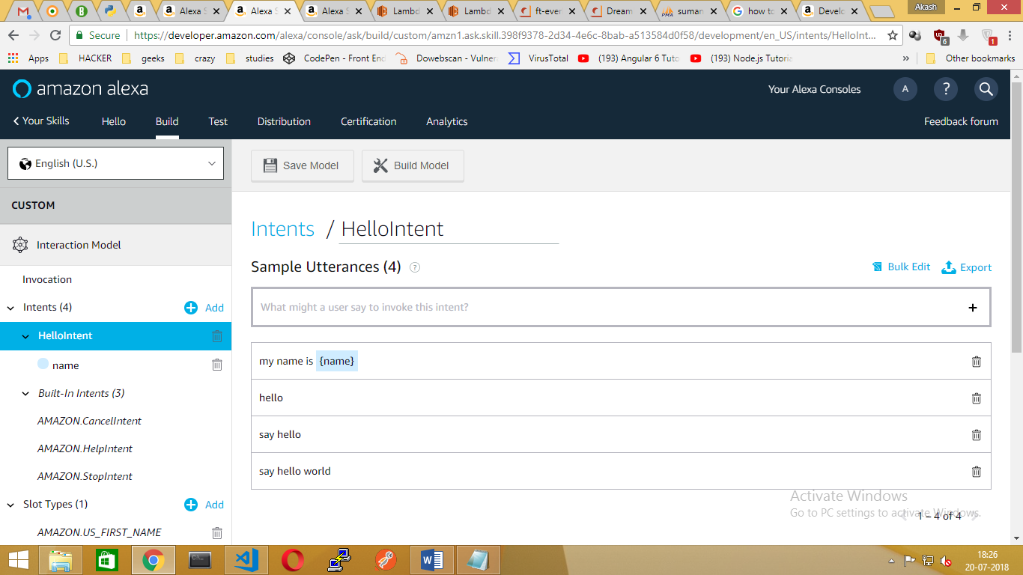

**(OR)**

We can also Create Interaction Model using JSON file

1. Go to Interaction Model section, Scroll down to JSON Editor and Paste the JSON Contents into it.



1. Finally, click “save model”.

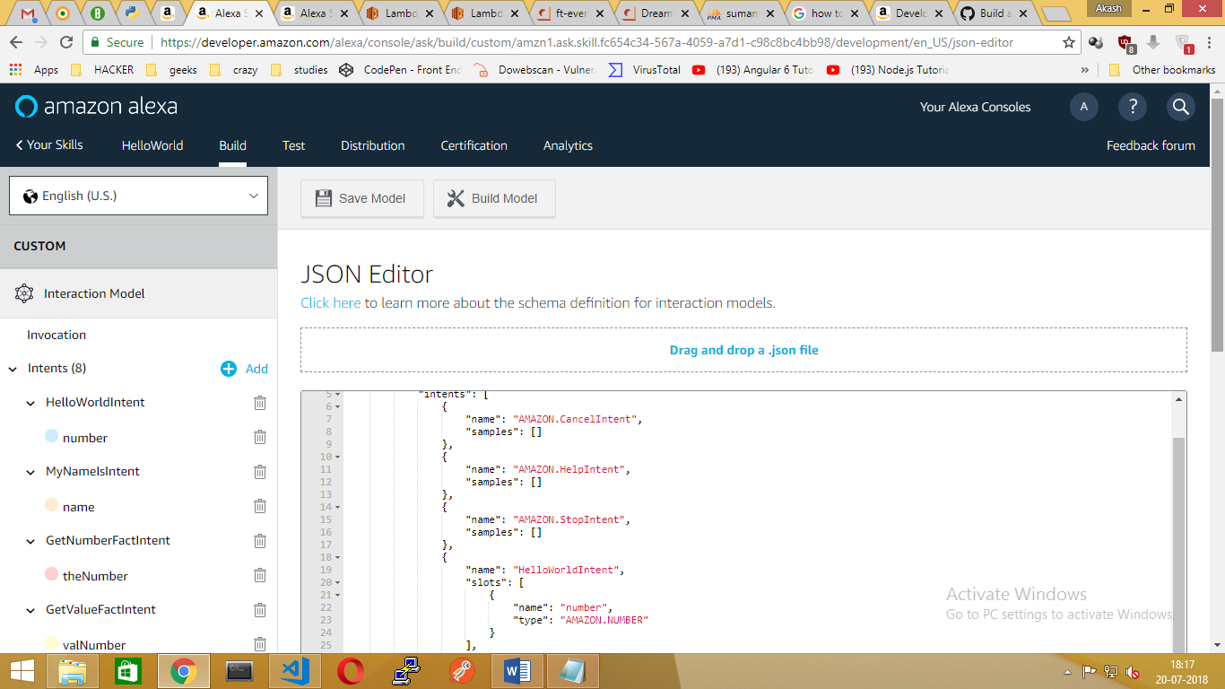

# **Create the Lambda function**

Now let's setup the Lambda function:

1. Go to <https://console.aws.amazon.com/console/home> and sign in
2. Go to Services > Compute > Lambda
3. Click on Create Function
4. Step 1: Click on Author from scratch
5. Step 2: Configure your Lambda function
   * Name = SampleLambdaFunction (or whatever you want)
   * Role = Create a Custom Role which will launch a new tab. Click Allow to create a new role named lambda_basic_execution and automatically insert this role into the Lambda basic information dialog.
   * Click Create Function
6. Step 3: Click Triggers -> Add Trigger and select “Alexa Skill Set”
   * Application Id = skill ID of your test skill that you noted above(from ENDPOINTS in Interaction Model)
   * Enable trigger = checked
   * Click Add
7. Step 4: Click Configuration
   * Runtime = (you can choose whatever you want. (.ie.nodejs)
   * Code entry type = Upload a .ZIP file
   * Click on Upload and find the **FILENAME.zip** (Contains **Index.js** & **node modules** Folder) you created earlier



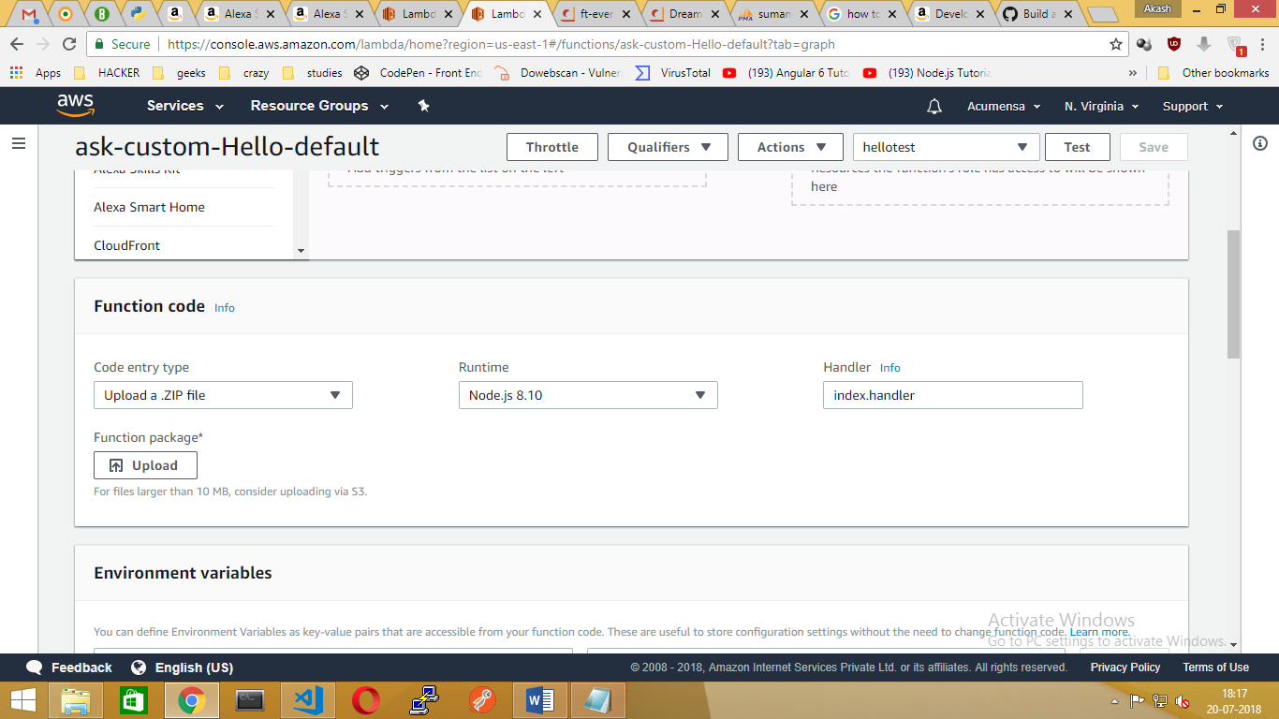

* + Click Upload
  + Click Save

1. Lambda ARN:
   * On the top right corner, note the Lambda ARN
   * Copy_ARN:arn:aws:lambda:us-east-1:970252137606:function:ask-custom-Hello-default

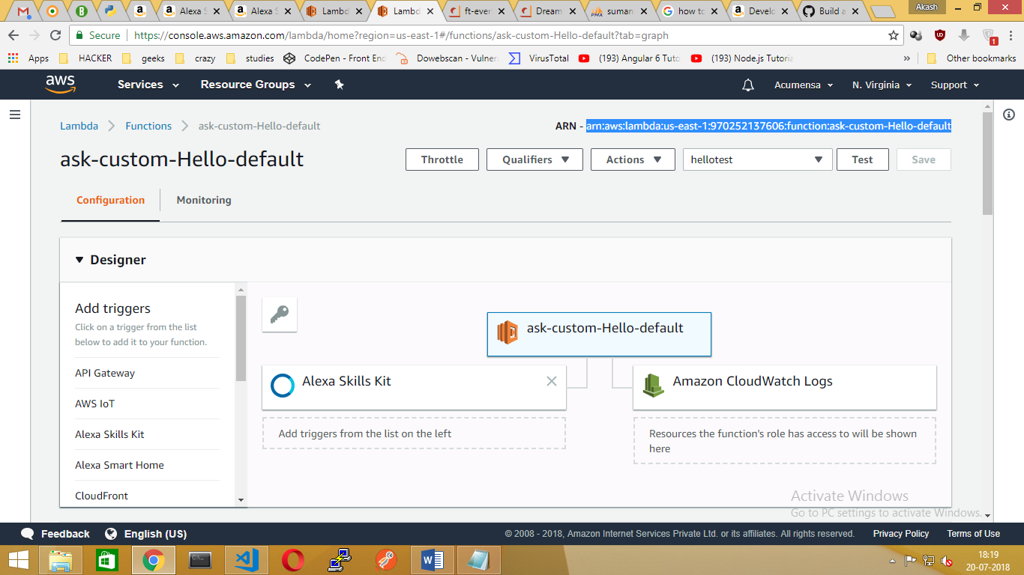

# **Configure skill**

* + Go back to <https://developer.amazon.com/home.html> and sign in as needed
  + Go to Alexa > Alexa Skills Kit > the test skill you created earlier
  + In the Configuration tab:
  + Lambda ARN default = enter your Lambda ARN noted from the previous step

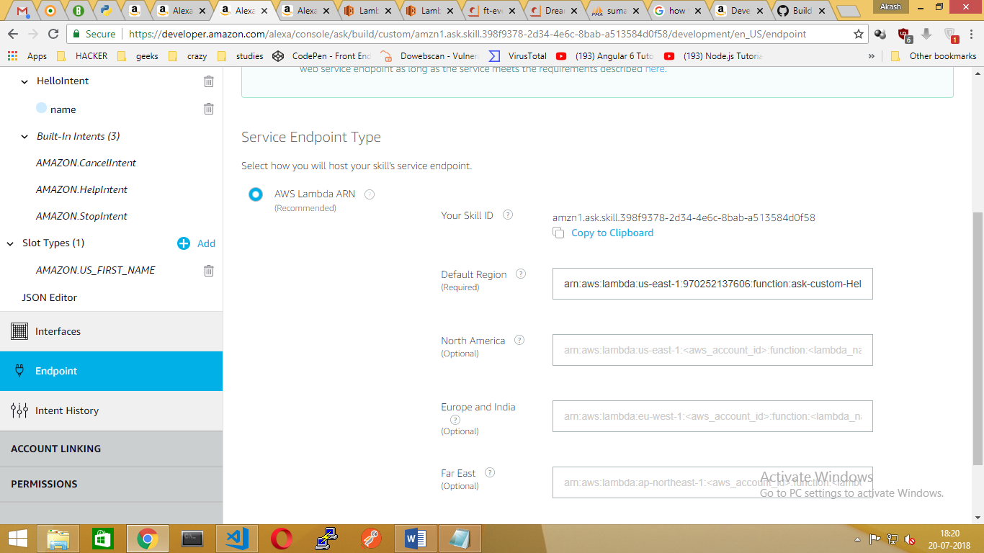

* + Finally, Click Save Endpoints.
  + At last, Click “Build Model” in Invocation Name

# **Testing skill**

* + Go back to <https://developer.amazon.com/home.html> and sign in as needed
  + Go to Top > Right next to Build section > Test
  + Click it, then enable “Test is enabled for the skill”.
  + Click “Alexa Simulator” on left hand side, then Type you INDENTS to check whether we are getting Skillset Output on right hand side will show JSON Input and JSON Output.

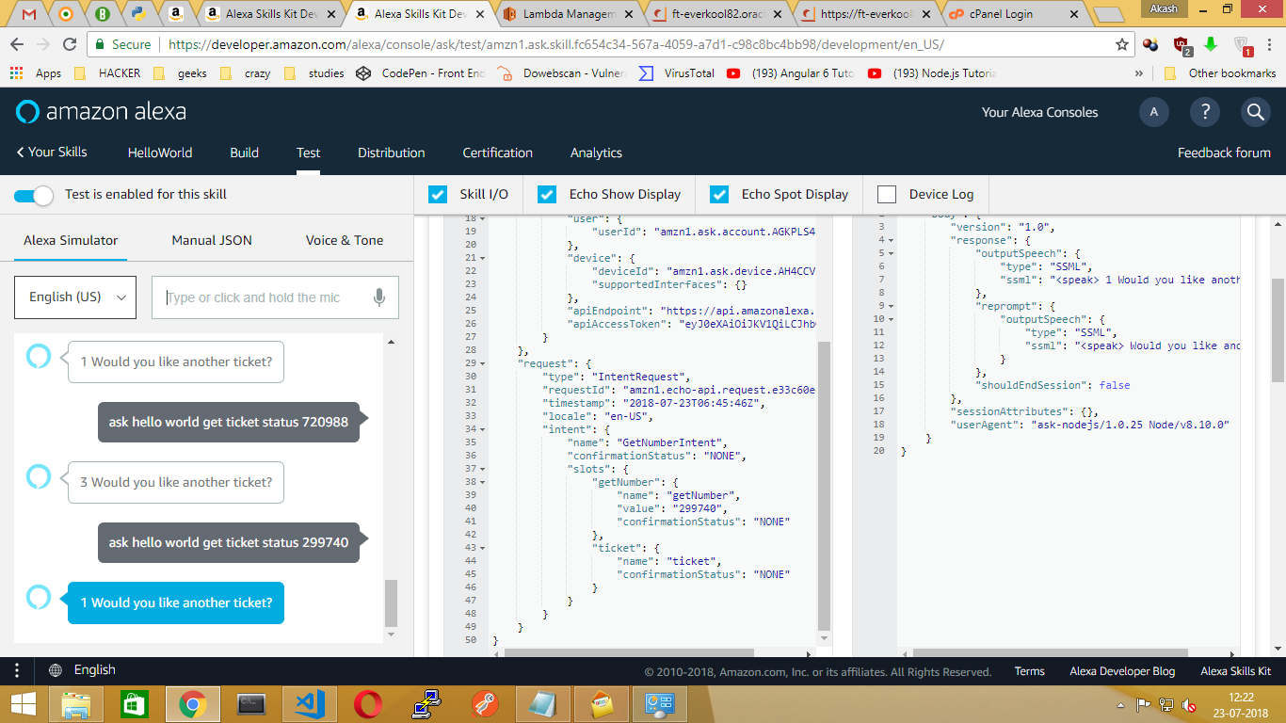

* + If any error message occurs then
  + Go to <https://console.aws.amazon.com/console/home> and sign in
  + Go to Services > Compute > Lambda
  + Click on Your Function to test

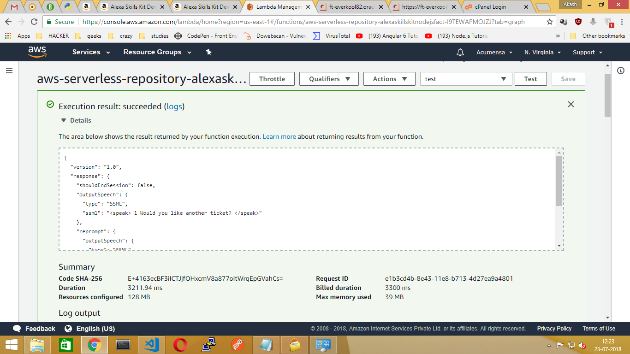

* + Click “Test” option on right corner

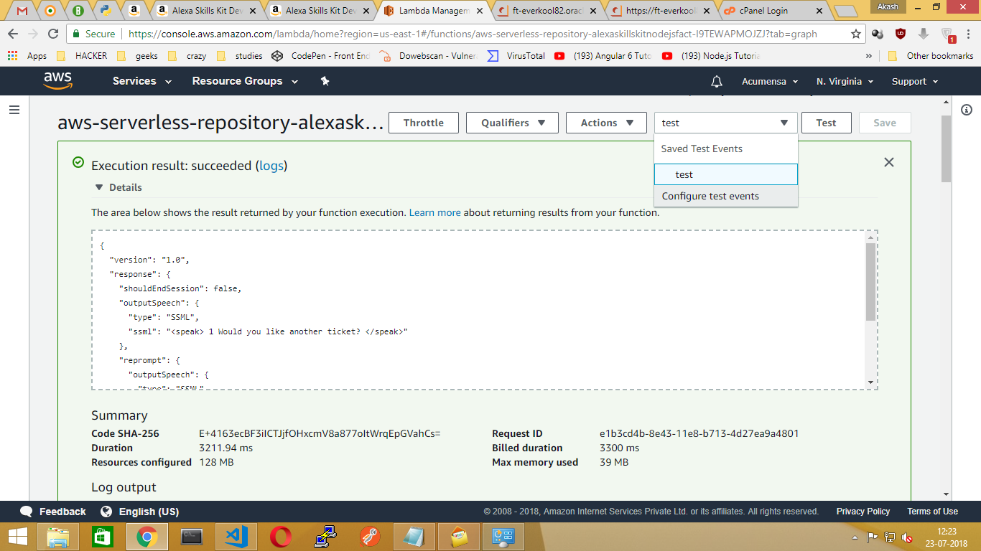

* + Click “Configure Test Events” and it will popup window

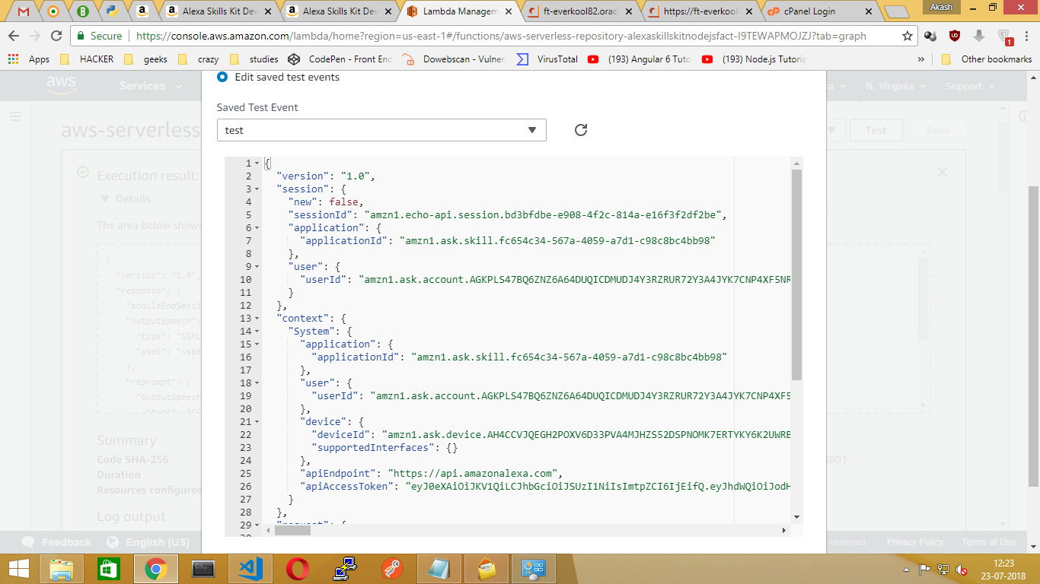

* + Paste your “Copied JSON Input “
  + And give the name to “Test event” and click Save.
  + Finally, Click TEST option on right Hand side to find where we are doing mistake.

# **Publishing the skill to ALEXA skill store**

* + Go back to <https://developer.amazon.com/home.html> and sign in as needed
  + Go to Top > Right next to Test section > Distribution
  + Click on “Skill Preview” and it will show list of languages supported by your ALEXA app.
  + If you want to add More Languages, Go back to <https://developer.amazon.com/home.html> and sign in as needed
  + Go to Top > Click on English (US) > Language settings to add.

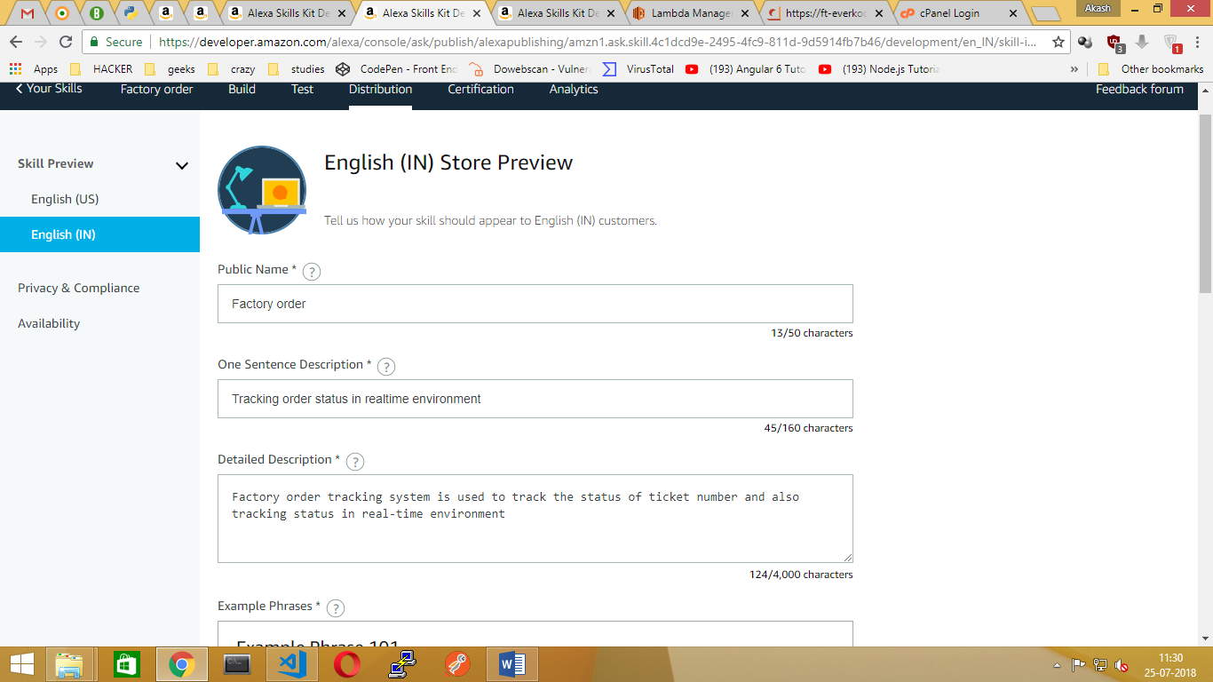

* + Fill the particular details and click “save & continue”

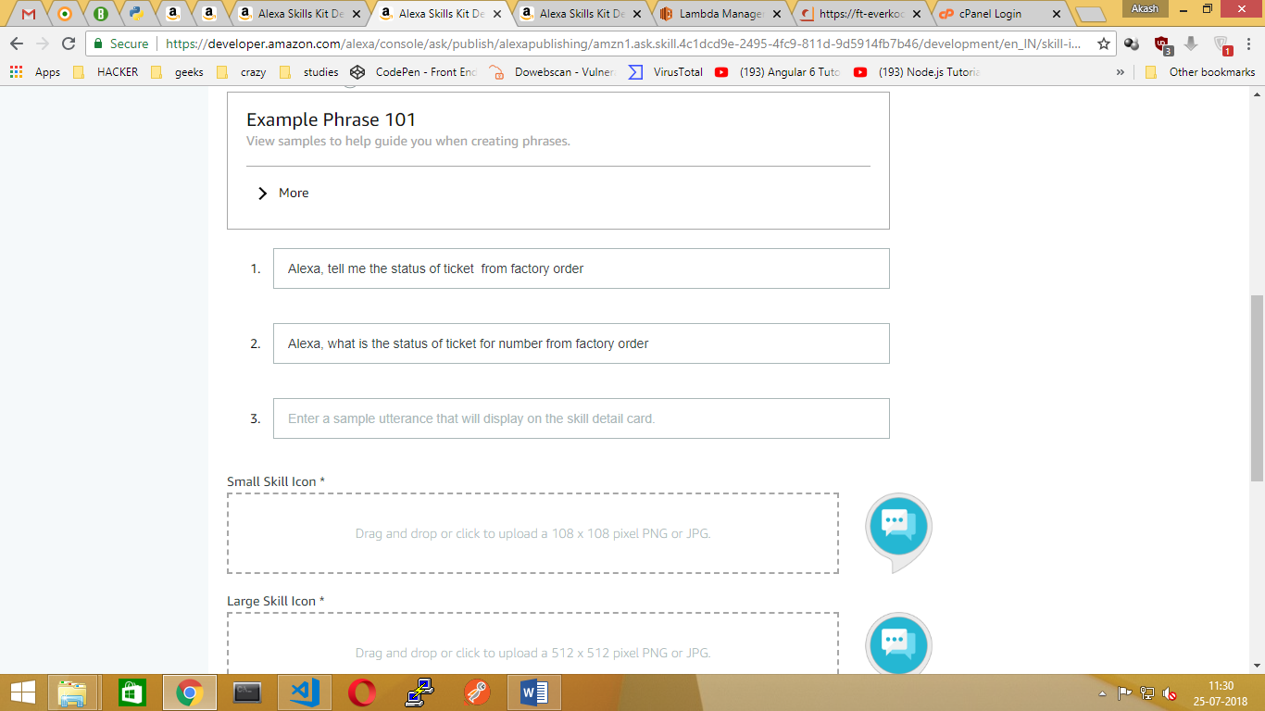

* + Redirecting to “Privacy & Compliance” and Fill out necessary details
  + Click “Save & continue”.

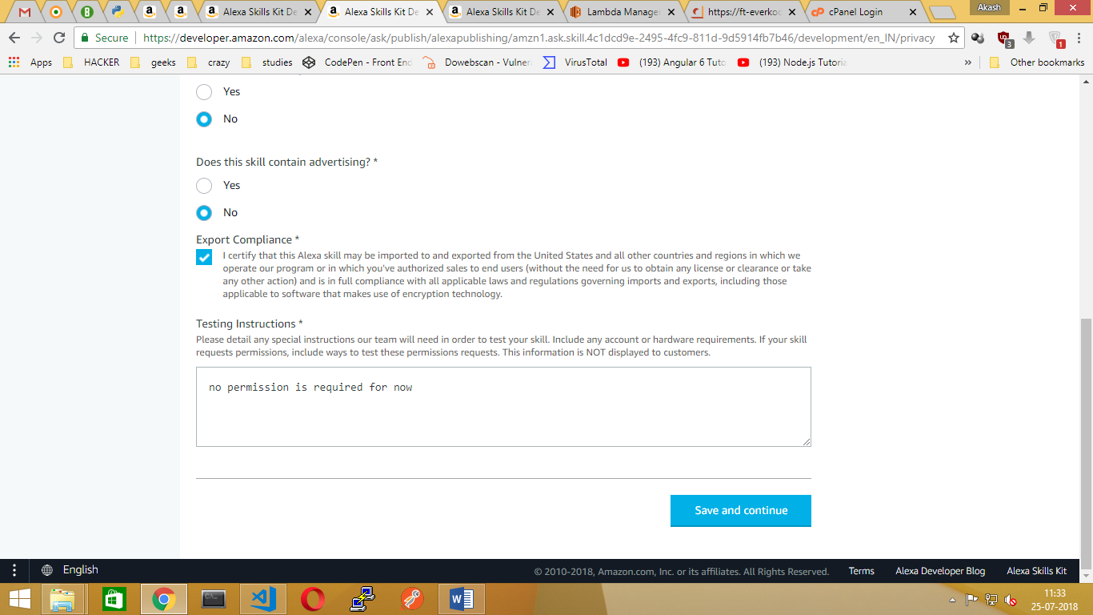

* + Redirecting to “Availability” and Fill out necessary details
  + Click “Beta Testing” to Give access to skill beta testers by adding their “email address”

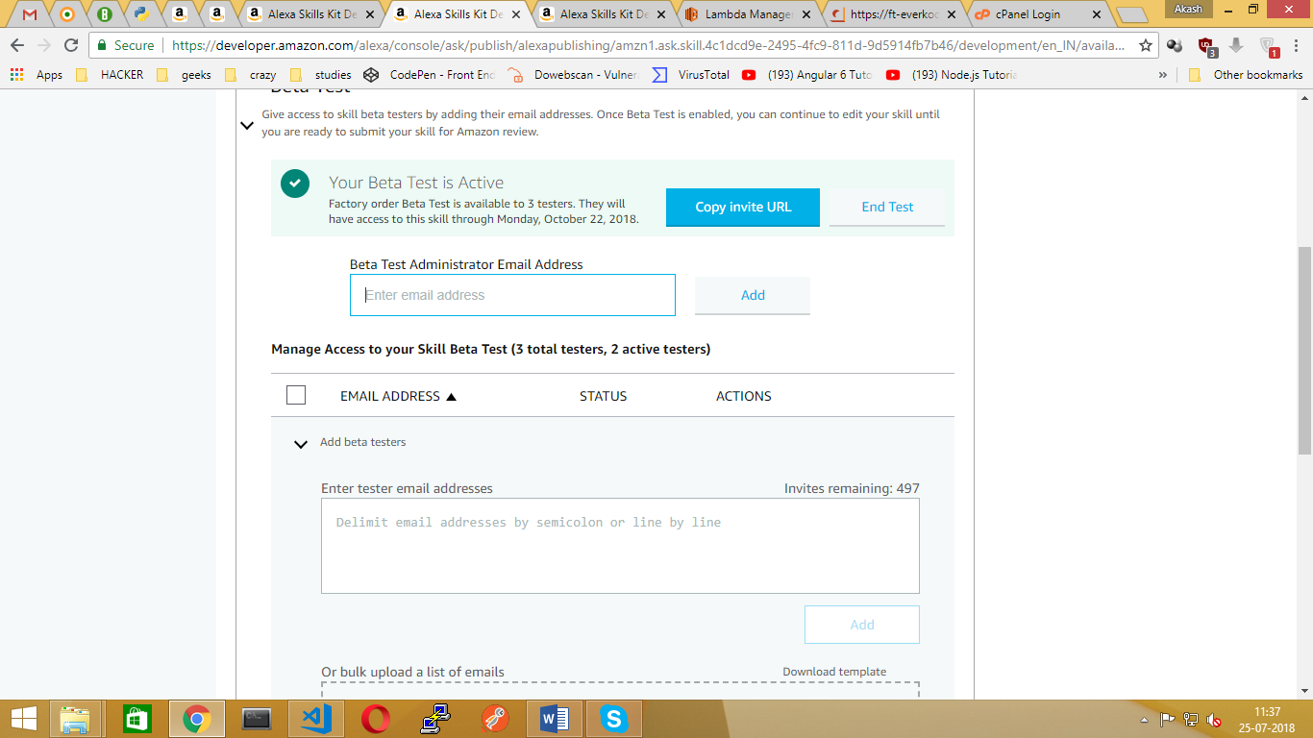

* + Click “Save & continue”.
  + Redirecting to “validation” page and their we will check if any error occurs in your SKILLSET to check.

# **Issues & Solutions**

**ISSUES:**

* 1. Alexa Response Speech outlet is working fine in CLI panel (i.e. <https://developer.amazon.com/home.html> -> test section) but not getting response in ALEXA app.
  2. Table does not exist in database from dream factory while Calling REST api.
  3. User not authenticated error while passing API to browser

**SOLUTIONS:**

**ISSUE** - 1: Alexa Response Speech outlet is working fine in CLI panel (i.e. <https://developer.amazon.com/home.html> -> test section) but not getting response in ALEXA app.

* + First we need to check whether using our region or default language from “language settings” in Amazon developer website.
  + If not means then “add specific language” and once again go to “Distribution” panel in (amazon.developer.com) redo the process to reflex in ALEXA app.

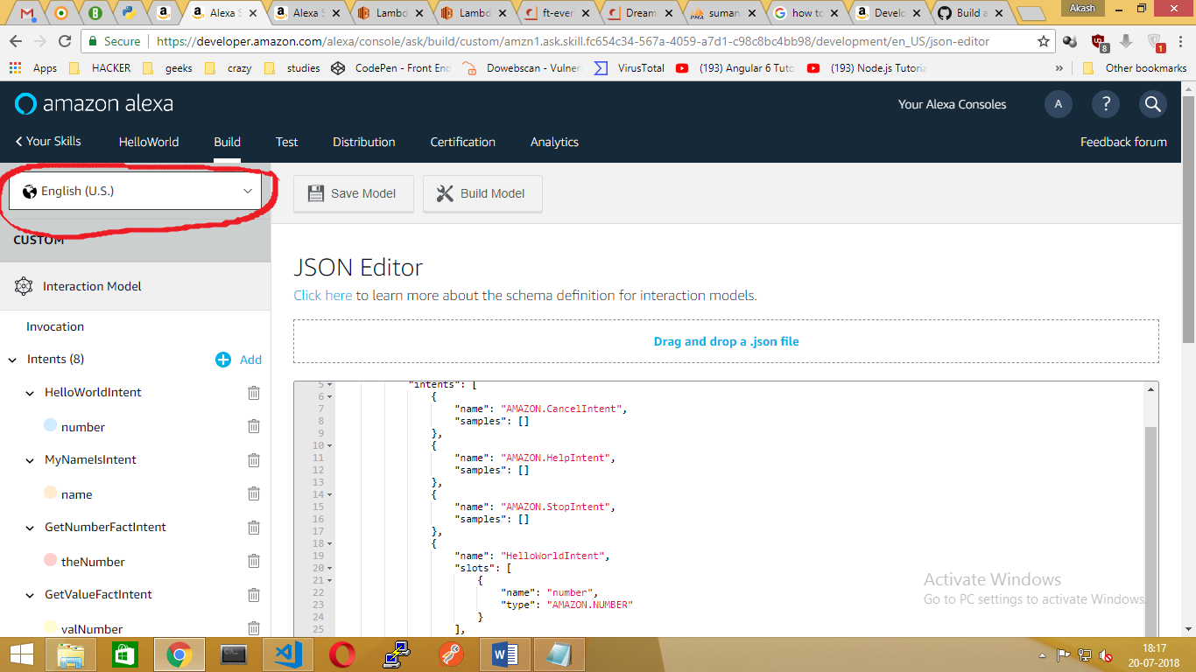

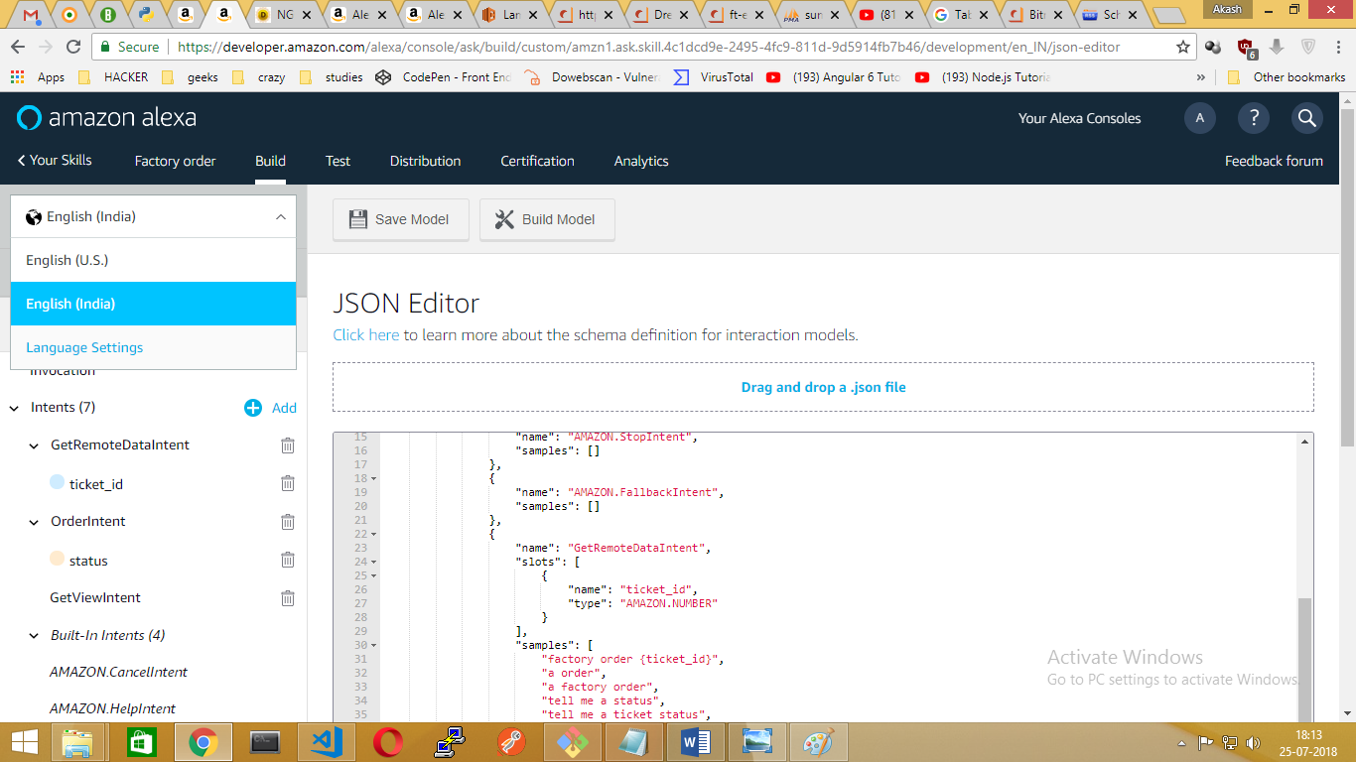

**ISSUE** - 2: Table does not exist in database from dream factory while Calling REST api.

* + In the admin console go to the “Config” tab and “Flush the system cache”.
  + Reload the admin console in your browser.
  + Then go back to the Schema tab and see if your table is there.
  + If you are having trouble building schema with the UI try importing the entire schema as JSON from the schema tab.

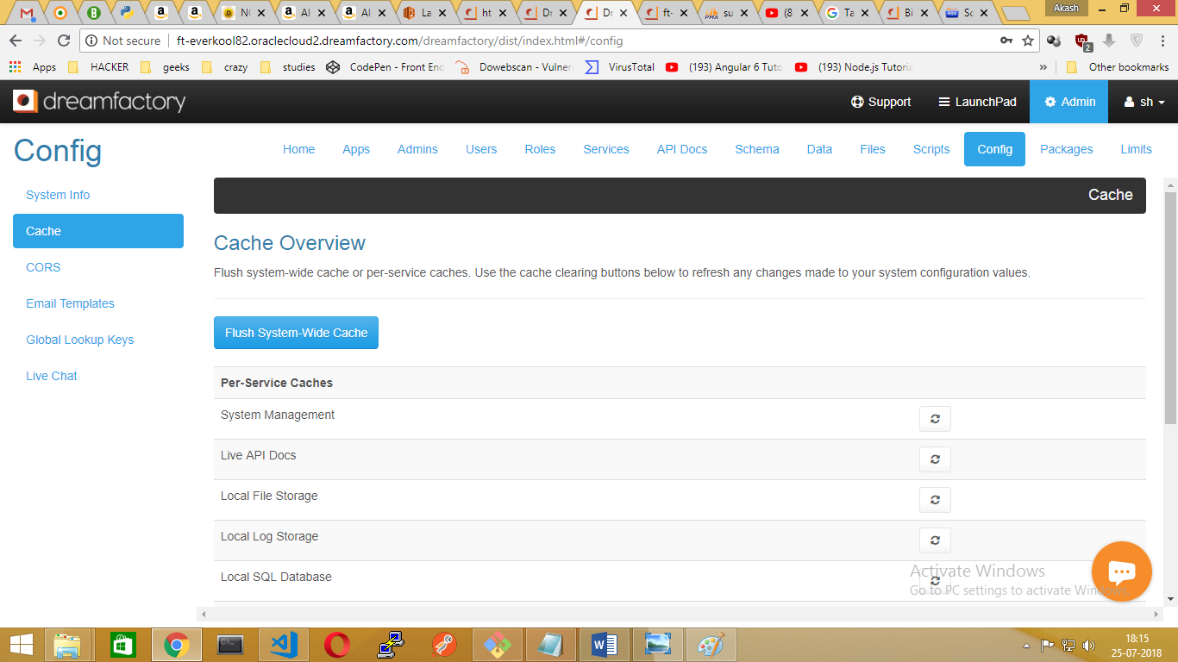

**ISSUE** - 3: User not authenticated error while passing API to browser

* + In the admin console go to the “APPS” tab and right hand side click “Create” option.
  + Fill the required fields and Click “Active”.
  + Select the “Role” where you created in “Roles” tab to assign to app.
  + Give the “app location” which one you want (i.e. By default you can give it to “No Storage Required”

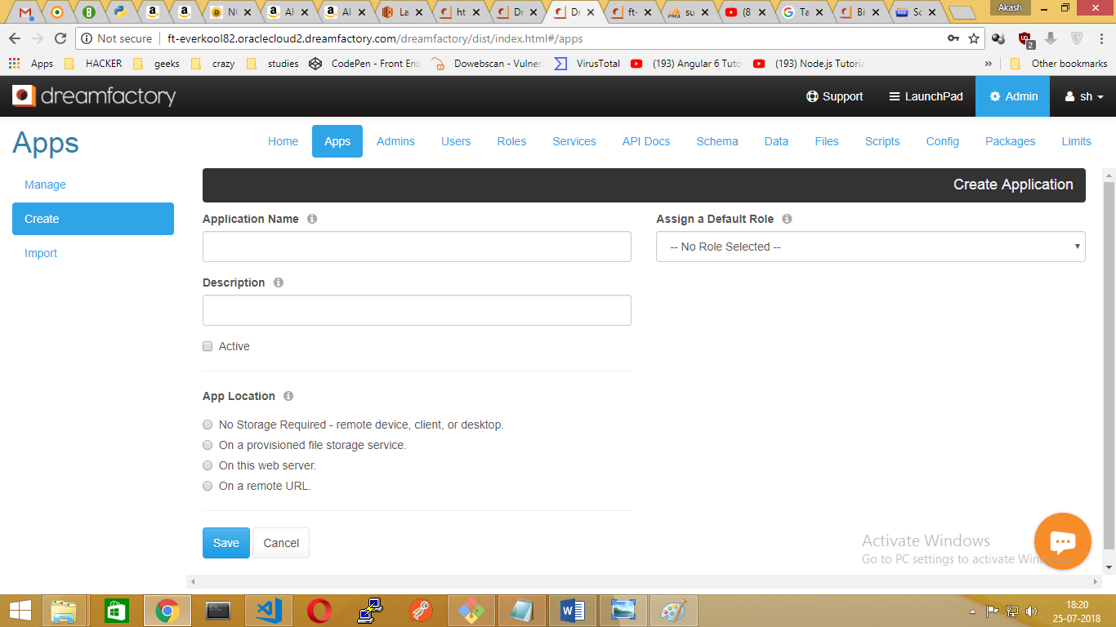

* + In the admin console go to the “APPS” tab and right hand side click “Create” option. Fill the required fields and Click “Active”.

